# Common pitfalls and solutions

**Problem: Nothing returned after modifying code, pasting in example $search**

Evidence: No output after submitting a query in the application

## Possible causes:

## Wrong name used in the creation of search index. Accepting “default” as the index name in “Create Atlas Search Index” in Atlas

1. Search Index not created or created against the wrong collection. I.e. Authors.

Solutions:

1. Verify that the search index was created with name “**fulltextsearch**”. It should be named "[fulltextsearch](https://mongodb-developer.github.io/search-lab/docs/search/search-index)" and not "default"

## Problem: No books showing in the library management app main screen.

Solution and Suggestions: Verify that you have completed the following:

1. Captured the connection string from your Atlas cluster.
2. Launched the library management loader script - can be found here: <https://library-scripts-ofiejy7uia-uc.a.run.app/>.
3. Created the vector search index and noted the name of the index you created.

## Problem: No results returning when running the aggregation pipeline examples and samples.

## Solution: You may be running the aggregation pipelines in the authors collection rather than the books collection.

## Search Lab: running Aggregation Pipelines in authors collection instead of books

[Here](https://mongodb-developer.github.io/search-lab/docs/aggregations/search-stage) we ask the attendees to use aggregations in the Atlas UI. The 1st collection that will be selected is "authors", they should select books.

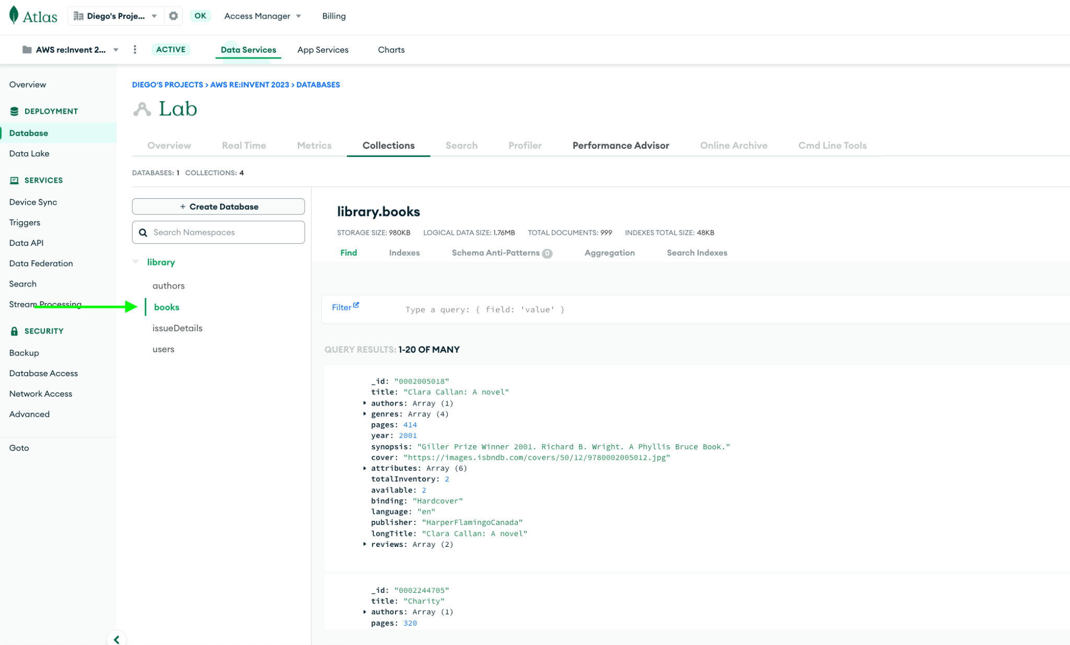

## Search Lab: doing the Books of the month exercise

They can check if it's working by looking if they appear as Books of the month in the client UI.

## Vector Search: creating the index

When creating the vectorsearch index definition, use Atlas Vector Search JSON Editor, **NOT** Atlas Search JSON Editor

## Vector Search: choose the right provider to import embeddings and create the indexes

Here remind them to choose the right provider. Depending on the provider the embeddings will have different dimensions (you can check that in Atlas, looking at the size of the embeddings array)

Once we go on to create the indexes we need to choose the right provider.

**Problem: No results returned by aggregation pipeline against the books collection.**

Possible Solutions:

1. Missing or wrong-named vector search index in Atlas Search.
2. Missing embedding field. Fix: The embedding field is not indexed correctly. Rebuild the search index with the correct name.

Troubleshooting:

* Check the terminal for errors. If needed, you can restart the server by typing ‘rs’ and hitting ‘Enter’.

Common terminal errors:

MongoServerError: PlanExecutor error during aggregation :: caused by :: vector field is indexed with 1408 dimensions but queried with 768

Fix: rebuilt the index with the correct dimension:

{

"mappings": {

"dynamic": true,

"fields": {

"embeddings": {

"dimensions": 768,

"similarity": "cosine",

"type": "knnVector"

}

}

}

}



MongoServerError: PlanExecutor error during aggregation :: caused by :: <field> is not indexed as knnVector

Fix: The embedding field is not indexed correctly. Rebuild the search index with the correct name.

* Go to src/controllers/books.ts and make sure the attendee is passing an embedding and not the query in the aggregation.
* Note the name of the index they’re using and if the syntax looks correct.
* Go to Atlas and make sure they have:
  + 1. Re-imported the books collection with the embeddings for the correct provider. Make sure you know how long the embeddings array is for the provider you’re using on the day.
  + 2. Created the vector search index with the correct name: vectorsearch.
  + 3. Open the search index configuration and make sure it’s the right one for the provider you’re using: <https://mongodb-developer.github.io/search-lab/docs/vector-search/create-index>